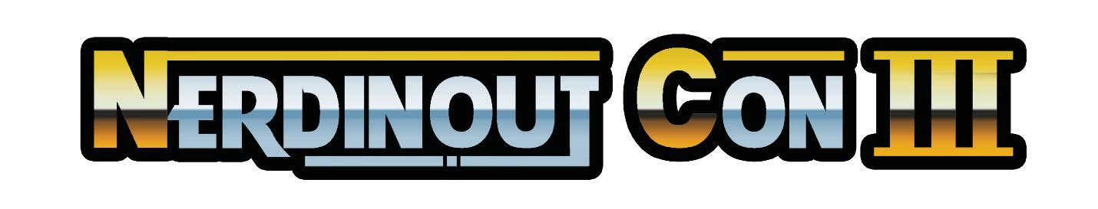

GENERAL DETAILS REGARDING VENDOR & ARTIST REGISTRATION
Thank you for choosing NerdinOut Con as a possible spot on your 2021 tour. We pride ourselves on offering a professional show with plenty of selling opportunity for our participating vendors. Due to this, we have a different process and rules than other shows. Please read the following rules and details before applying. Links to the applications will be further down.
Application & Selection Process
NerdinOut Con uses an application process in choosing our vendors and artists for the year, rather than accepting on a first come-first serve basis. We wish to offer spaces with a variety of different merchandise to our attendees, which in turn offers a better selling chance for everyone. Sending in the application does not guarantee you a space!
Payment
If accepted, we will send you your paperwork and an invoice for your payment to the e-mail you list on your application. Payment is done through check or online payment through PayPal to the event company only never with cash or checks made personally to a member of staff. Once you have been accepted and deposit payment has been processed, your space will be reserved for the event. A 50% minimum payment is required in order to reserve your space.
Cancellation Policy
The following is the return/refund policy for our booth spaces:
- Cancelling prior to June 31st, 2021: 50% of payment returned.
- Cancelling after June 31st, 2021: No refund.
Committee Selection Process
We will begin our first period of Committee selection starting March 2021.

VENDOR REGISTRATION
The standard 10′ x 10′ space is $250 (limit 2 per business, unless prior approval is given). Add an additional available 10’ x 10’ space for $150 extra. Pipe and drape, table and chairs provided with each space. Electricity is available at $100 extra for the weekend ( Friday, Saturday, Sunday) Available through the Civic Center. (details will be provided in your acceptance paperwork). Each business gets 2 free badges with their first 10 x 10′ space purchase (limit 4 total badges per business, unless prior approval is given.) Additional badges are $30 additional.
Rules
Selling Food: No food sales are allowed
Alcohol: The selling of alcoholic beverages is strictly prohibited.
Adult Materials: While the selling of 18+ items is allowed, we ask dealers to use discretion when displaying these items. We have a good number of attendees who are under the age of 18, who may or may not be with their guardians. Only attendees who are 18 years and older may view and purchase these items.
Noise: Please avoid using excessive noise or disruptive behavior to attract attendees to your booth.
Bootlegs: The selling of bootleg merchandise is strictly prohibited. If there is a complaint or comment regarding a piece of merchandise, we ask you work with our representatives on evaluating if the item is official or bootleg. If it is a bootleg, we ask your compliance in removing the item from your inventory for the remainder of the event. Failure to comply may result in ejection from the event without refund. If a majority of a dealer’s inventory is found to be bootleg, they will be asked to leave the show without refund.
Unlawful merchandise: Items that are deemed illegal for sale in the state of Minnesota or in the United States of America are not allowed.
Fan Art and Use of Licensed Characters (In the case of artists requesting a dealer’s booth, or dealers selling art they’ve created in addition to retail stock) – Fan art is allowed at NerdinOut Con as long as the composition is fully created from scratch. All fan made works must be original creations in regards to composition and cannot be recreations of another person’s fan-made works, or a show's promotional images.

ARTIST REGISTRATION
Each space is $175 (limit one space per artist or artist group). Pipe and drape, an 8′ table with each space. Add an additional available 10’ x 10’ space for $100. Electricity is an extra $81 for the entire weekend. Each space comes with 2 badges additional badges available for $30 each, maximum 4 per artist.
Rules
Fan Art and Use of Licensed Characters – Fan art is allowed at NerdinOut Con as long as the composition is fully created from scratch. All fan made works must be original creations in regards to composition and cannot be recreations of another person’s fan-made works, or a show's promotional images. No items may be sold that contain traced reproductions, screenshots or image captures from shows, manga, etc. Titles of shows, properties, and their trademarks cannot be used to advertise the merchandise (ie, advertising Deadpool fan art with a sign that contains the name Deadpool or the logo from the show).
Table Sharing & Proxy Vendors – Table sharing is allowed at NerdinOut Con between consenting creators as long as the booth space is paid for in full. We ask that the artist who created their pieces be in attendance at NerdinOut Con, if possible. If the artist is attending multiple shows and requires a proxy, friend, or employee to be at the show in their place, we ask that the applying artist send us an e-mail clarifying who their representative(s) will be for our records. If a representative is selling works made by multiple artists, they need to provide proof they have the consent of the artists to sell their productions.
Adult Materials: While the selling of 18+ items is allowed, we ask artists to use discretion when displaying these items. We have a good number of attendees who are under the age of 18, who may or may not be with their guardians. Only attendees who are 18 years and older may purchase or see these items.
Noise: Please avoid using excessive noise or disruptive behavior to attract attendees to your booth.

Exhibitor Name _______________________________

Items Sold ____________________________________

Contact Person _______________________________

Address _______________________________

City State Zip _______________________________

Phone # ( ) _______________________________

E-MAIL: _______________________________

I understand and agree to the terms of this contract.

Signature Date _______________________________

Title _______________________________

Electricity

Additional Space How Many ________

Additional Badges
(2 included)

